School of Computer of Science

ASSIGNMENT BRIEFING SHEET (2019/20 Academic Year)

Assignment Title | Assignment 1 Part 2 | Date Submitted
Module Title | WAN Protocols and Cybersecurity | Module  Code | 5FTC1331

Tutor | Seyedali Pourmoafi | GROUP or INDIVIDUAL Assignment | Individual

FOR INDIVIDUAL ASSIGNMENTS – STUDENT TO COMPLETE

(Comments on this assignment by students can be made on the back of the assignment briefing sheet).
By completing BOX, A below, I certify that the submitted work is entirely mine and that any material derived or quoted from the published or unpublished work of other persons has been duly acknowledged. [ref. UPR AS12, section 7 and UPR AS14 (Appendix III)].
Please print your forename and surname in capitals and provide your ID (srn) number.

BOX A
Student Forename  (in CAPS please) | Student Surname  (in CAPS please) | Student ID Number (SRN) | Signature of Student

FOR GROUP ASSIGNMENTS - STUDENTS TO COMPLETE

Group Name/Number (if allocated by module team) | N/A

(Student comments on this assignment can be made on the back of the assignment briefing sheet)
By completing BOX B below, we certify that the submission is entirely ours and that any material derived or quoted from the published or unpublished work of other persons has been duly acknowledged. [ref. UPR AS/C/6.1, section 7 and UPR AS/C/5 (Appendix III)].
Please print your forenames and surnames in capitals, provide your; - ID numbers, actual time spent on the assignment and your signatures. By signing the submission, you certify that this work represents equal contributions from all team members. If this is not the case, the module leader must be informed before submission.

This sheet must be submitted with the assignment, signed and either BOX A or B filled in.
LATE SUBMISSION WILL ATTRACT A STANDARD LATENESS PENALTY.
- For undergraduate modules, a score of 40% or above represents a pass mark.
- For postgraduate modules, a score of 50% or above represents a pass mark.
- For work submitted up to 5 working days late marked is capped to a bare pass (40% for undergraduate and 50% for postgraduate).
- For work submitted more than 5 working days a mark of zero will be awarded for the assignment.

School of Computer of Science

ASSIGNMENT BRIEFING SHEET (2017/18 Academic Year)

THE ASSIGNMENT TASK: see attached

MODULE LEARNING OUTCOMES ASSESSED BY THIS ASSIGNMENT: see attached
SUBMISSION REQUIREMENTS: see attached
FEEDBACK FROM THIS ASSIGNMENT see attached
MARKS AWARDED FOR:

see attached feedback sheet

DEADLINES AND ASSIGNMENT WEIGHTINGS
1 | This assignment is worth |  | 25% |  | of the overall assessment for this module.
2 | You are expected to spend about |  |  | 25 |  | Hours to complete this assignment to a satisfactory standard
3 | Date assignment set | 29/01/2020 |  |  |  | Date completed assignment to be handed in
4 | Target date for return of marked assignment

INTERNAL MODERATION
This assignment has been internally moderated. I confirm that the assignment set, meets the requirements of the module and that the brief provides appropriate content for students to successfully complete the assignment. | Moderator name, signature and date

FOUNDATION DEGREE – Computing Technologies Level 5
Mark: □

College: NHC / WHC ______

Tutor Name: ___Seyedali Pourmoafi__

Module Name: WAN Protocols and Cybersecurity

Module codes: 5FTC1331

Assignment No: Assignment 1

Date Issued: ______29 January 2020 __

To be submitted by: ______

Learning Outcomes:

- K1 - Describe and differentiate WAN technologies and network management principles used to connect near and distant business networks.

- K2 – Analyse and evaluate WAN security concepts and general methods for mitigating common security threats.

- S1 – Use appropriate WAN technologies and protocols to connect various segments of an enterprise WAN network.

- S2 – Apply WAN protocols and services used to securely connect remote networks and the WAN principles at the basis of the Internet

Feedback Comments to Students:

Comments from Moderators:

 | Print Name and Sign | Date
Assessor

Internal Moderator
Cross-Moderator

Scenario:
T1 Electro the organisation that designs, builds and sells Lithium Ion Polymer batteries for use in electric cars is growing very successfully. The management have analysed their recent and predicted growth patterns and decided they require a connection to a remote server farm in order to securely back up their innovative designs and technologies. In addition to increase productivity and flexibility they have also decided that employees should be to be able to securely access the corporate network remotely via a secured dial-up connection. Company policy dictates that these two important requirements should be designed, implemented and tested in an advanced network simulation application before they are rolled out on the live network. You should use the prototype you configured in assignment 1 of Network Protocols and Cybersecurity as a starting point for the new prototype. Make use of Cisco Packet Tracer in order to demonstrate how the new network structure will work. A physical topology of the network has been provided below. The additional IP addressing for the server farm and remote access VPN is completely your responsibility.

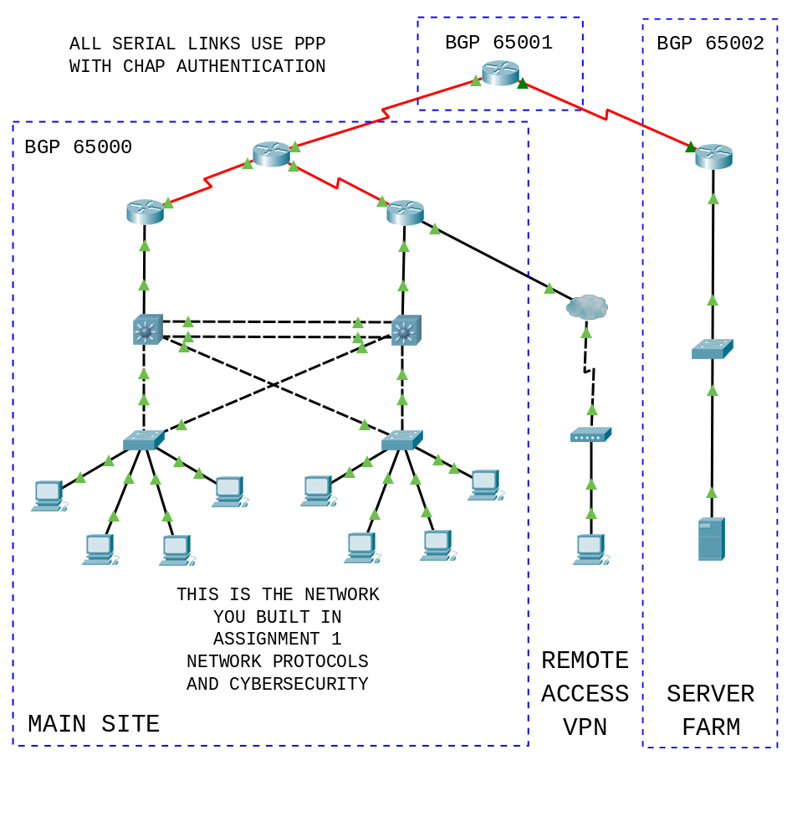
You will note that external BGP is now used for inter-AS connections and PPP with CHAP authentication is used to add an additional layer of security to the serial links.

Using Cisco Packet Tracer build and configure the network in the diagram on the previous page. Carefully read the requirements below as they contain important information on how to proceed, pay particular attention to the marking scheme checklist to ensure that you have completed all of the required tasks. Full connectivity is required between all end devices across the whole network in the above diagram.
Requirements:
- You will need to study the network diagram on the previous page in order to understand and interpret the physical topology. This physical topology has not been created by you, so you will need to ask questions in order to fully understand what is required from you. A list of meaningful questions will need to be written and submitted with the written part of the assignment. The questions will be answered in a 15-minutes one-to-one meeting with the client representative (your tutor).

- You will need to configure the network according to the proposed design. The network will be tested using functionality testing. Your tutor will ping and trace across various paths, they will also use Cisco show commands to verify the correct operation of PPP, eBGP and the remote access VPN. This last task is quite a challenging configuration that makes use of AAA, encryption and hashing technologies and will require good research skills and some experimentation using Packet Tracer to configure successfully.

- You need to provide a report of 1200-1600 words where you show:

  - A list of meaningful questions that you prepared for the meeting with the client in order to clarify the requirements and a rationale showing your understanding and interpretation of the requirements. Your questions should demonstrate an understanding of the technical requirements that should be considered in order to implement the technologies you will be configuring. Five questions should be asked and each question can receive a maximum of two marks, therefore a total of ten marks can be achieved for the questions.

  - A detailed IP addressing scheme for the new additions to the T1 Electro network that is carefully and clearly explained.

  - An explanation of router configurations required to meet the customer requirements and commented screenshots of testing the connections on Packet Tracer Simulator command line option. Ensure that you include a screenshot of the remote access VPN in its fully connected state, this can be achieved by using ipconfig on the remote workers PC and an appropriate Cisco CLI show command(s) on the R3 router.
For reporting on router configuration, just copying and pasting some commands is not enough. The syntax of the commands can change from one platform to another and from one manufacturer to another, it is the process that needs to be explained. You will be using Cisco router commands to explain configuration steps that can otherwise be done on any other types of routers but just with different syntax. As you will need to do some research of BGP, PPP and RA VPN’s, you need to use Harvard referencing to cite your sources.

- Submission requirements – on Canvas before the deadline shown on the front cover. You will submit two files – the final Packet Tracer simulator file for your prototype and a report.

Marking scheme for Assignment 1:

Assignment 1 Checklist | Percentage awarded
A list of meaningful questions for the client and a rationale demonstrating the understanding of the requirements | 10%
The initial configuration on the prototype works correctly and the all the devices can ping their default gateways | 5%
PPP with CHAP authentication is configured correctly | 5%
eBGP is configured correctly, tested by looking for BGP peers, BGP network advertisements and BGP routes. | 5%
The remote access VPN is fully functional. This should be tested by pinging across the VPN connection into the corporate network and by ipconfig on the remote workers PC and appropriate show commands on the VPN endpoint router R3. | 20%
Technical explanations are given throughout the report about the configuration of the network, which show a very good understanding of PPP (with CHAP authentication), BGP and RA VPN’s. | 40%
The report is well-structured and shows very good report writing skills | 10%
Harvard referencing is properly used, and all sources are cited in the text and reference page | 5%
TOTAL | 100%

Numeric Grade |  | Descriptor  (class. band) | Undergraduate Generic Grading Criteria
Numeric Grade |  | Descriptor  (class. band) | Communication:  Presenting work, use of appropriate structures, methods, language, grammar and source materials, Harvard referencing | Demonstration of Knowledge:  Provide solutions that show knowledge of initial problems /  Configuration of default routes or route re-distribution | Application of Technology / Demonstration of Practical Skills:  Router configuration, use of applications, applying technology to problems | Ideas/Concept Development  Initial implementation of given designs,  Design and Implementation of IP addressing scheme | Analysis, Critical Evaluation and/or Reflection (with derivation of solution):  Demonstration of evaluation, testing and reflection.
80-100 |  | Outstanding  (1st class) | Outstanding presentation and clarity. No significant grammatical / spelling or structural errors. Ideas presented with exceptional clarity. Outstanding standard of referencing in text and highly accurate | Outstanding breadth and depth demonstrated. Outstanding integration of literature and/or theory into work.  Outstanding exploration and demonstration of topic showing in depth knowledge and understanding | Outstanding use of appropriate technology as applied to the problem domain. Occasionally stepping beyond expectations using sophisticated solutions. Consistently accurate and outstanding application of skills and techniques demonstrated | Solutions are novel & fully reframed task within context. Profound depth of engagement and incisive ideas development. Planning is meticulous; decision making is perceptive. Methodologies are used in an outstanding manner | Outstanding level of analysis, critical evaluation and/or reflection with outstanding application to derived solutions (where required).  Highly developed / focused work. Original and well-informed personal response
70-79 |  | Excellent  (1st class) | Excellent structure. Fluent writing style with very few errors. Very minor grammatical / spelling or structural errors. Ideas presented with excellent clarity. Excellent standard of referencing in text, and highly accurate | Excellent breadth & depth demonstrated. Excellent integration of literature and/or theory into work.  Excellent level of knowledge and understanding demonstrated. Covers all relevant points and issues. | Excellent use of appropriate technology as applied to the problem domain. Excellent and highly accurate application of skills and techniques demonstrated. Minor errors in technique and/or application with little or no impact on deliverables. | Solutions are innovative and partially reframe the task within its context. Considerable depth of engagement and successful ideas development clearly documented. Detailed planning and clear rationale for decisions. Methodologies are used in an excellent manner | Excellent level of analysis, critical evaluation and/or reflection of issues with excellent application to derived solutions (where required). Well-developed personal response
60-69 |  | Very good  (Upper 2nd class) | Very good clear structure. Articulate, fluent writing style and structure. Very few grammatical errors, spelling mistakes or structural issues. Ideas presented with clarity. Very good standard referencing in text, with very accurate use with minor errors | Very good breadth & depth demonstrated appropriate to topic.  Literature and/or theory integrated very well.  Very good level of knowledge and understanding demonstrated. | Very good use of appropriate technology as applied to the problem domain. High level and very accurate application of skills and techniques understanding demonstrated. Small errors in technique and/or application with little impact on deliverables | Solutions relate directly to task and may step beyond conventions  Strong engagement with subject material and processes, evaluation of alternatives, solutions come from process. Strong use of methodologies to derive solutions | Very good level of, analysis, critical evaluation and/or reflection but not consistently taken to full extent with very good application to derived solutions (where required). Partial personal response tends towards descriptive
50-59 |  | Good  (Lower 2nd class) | Good structure. Writing is mainly clear but some spelling and / or grammatical errors with some structural issues. Ideas presented with some issues in clarity Very good standard referencing in text, with very accurate use with some errors | Good use of literature/theory. Depth appropriate to topic BUT moderate breadth or vice versa. Literature and/or theory integrated into work.  Good grasp of the topic and some of its implications. Knowledge and understanding is demonstrated. Minor errors / omissions. | Good use of appropriate technology as applied to the problem domain. Good and reasonably accurate application of skills and techniques demonstrated. Some errors in technique and/or application with minor impact on deliverables | Solutions are appropriate to task, work well within conventions. Good use of subject material and planning processes, range of alternatives put forward and evaluated  Experimentation to support implementation within conventions Good use of methodologies to derive solutions | Good level of analysis and/or reflection but critical evaluation could be expanded on further. Good application to derived solutions (where required). Primarily descriptive personal response, sometimes restricted to immediate concerns
40-49 |  | Satisfactory  (3rd class) | Satisfactory structure. Not always written clearly and has grammatical and / or spelling errors. Ideas not always clearly presented. Satisfactory standard referencing in text, relatively accurate but showing errors | Satisfactory use of literature and/or theory demonstrated but limited in breadth OR depth. Uncritical and quoted without comment. Satisfactory content / level of knowledge of the topic. Addresses part of the question. Some errors / omissions. | Satisfactory use of appropriate technology as applied to the problem domain. Satisfactory application of skills and techniques demonstrated but with minor inaccuracies. Errors in technique and/or application with some impact on deliverables | Solutions limited to task and address conventions. Solutions found or adopted  Some planning but completion is rushed. Some experiments but limited alternatives. Methodologies are applied to derive solutions, but steps are missed. | Satisfactory level of analysis and/or reflection but limited evidence of critical evaluation. Satisfactory application to derived solutions (where required). Descriptive personal response mainly restricted to immediate concerns
30-39 |  | Marginal fail  (Fail) | Poor structure. Has many spelling and /or grammatical errors. Poor presentation of ideas. Limited referencing in text, reference use shows inaccuracy and/or many errors | Limited in breadth and depth demonstrated. Literature and/or used/quoted without comment. Limited content / knowledge. Limited or muddled understanding of the topic/question. | Limited use of appropriate technology as applied to the problem domain. Limited application of skills and techniques demonstrated. Many errors in technique and/or application with high impact on deliverables. | Solutions reframe task inappropriately and do not address conventions. Basic use of strategies, few alternatives, limited evaluation with limited experimentation. Limited use of methodologies to derive solutions. | Limited evidence of analysis, critical evaluation and/or reflection. Limited application to derived solutions (where required). Too descriptive in parts. Limited personal response.
20-29 |  | Clear fail  (Fail) | Lacking Structure –argument difficult to follow. Poorly written and/or poor spelling and grammar. Few clear ideas presented. Lacking referencing within text with a high level of inaccuracy. | Lacking in breadth and depth. Some literature and/or theory irrelevant to topic area. Lacking knowledge Content irrelevant / inaccurate.  Does not address the question and therefore does not meet the learning outcomes. | Very little use of appropriate technology as applied to the problem domain. Very little skill and application of techniques demonstrated. High number of errors with very high impact on deliverables. | Lacking in appropriate solutions with very limited use of strategies, no evaluation and little evidence of ideas development. Little use of methodologies | Lacking in its level of analysis / critical evaluation and/or reflection. Minimal application to derived solutions (where required)  Mainly descriptive, lacking in personal response.
0-19 |  | Nothing of merit  (Fail) | No discernable structure. Very difficult to follow. Many grammatical errors. Many spellings mistake. No presentation of ideas. Unsatisfactory referencing within text. Reference list does not match references in text.  References list has incorrect citations and/or is not the recommended format. No reference list included. | No / unsatisfactory evidence of literature and/or theory being referred to. Much of the literature and/or theory used irrelevant to topic area  No / unsatisfactory level of knowledge demonstrated.  Content not appropriate to the topic. | No use of appropriate technology as applied to the problem domain. No skill and application of technique demonstrated. Very high number of errors in deliverable or no deliverable submitted. | No or completely inappropriate solution. No use of strategies, no planning and no experimentation. No application of methodology | Unsatisfactory level of analysis / critical evaluation and or reflection. No application to derived solutions (where required)  Wholly descriptive. No personal response.

